Temporary Road closure Risk Assessment

Organisation Name | Cam Parish Council | Date | Tuesday 31 October 2023
Address | Cam Parish Council Office, 4 Noel Lee Way, GLOS, GL11 5PS | Email | projects@camparishcouncil.gov.uk
Assessors Name | Johanna Edwards, Projects Officer | Area/ Event Being Accessed | Road closure: from roundabout to China Chef: Cam High Street
Demographic expected | Mixed age, mixed gender, family | Describe in more detail what goes on here: | Community Christmas event: Public event, non-ticketed, public land

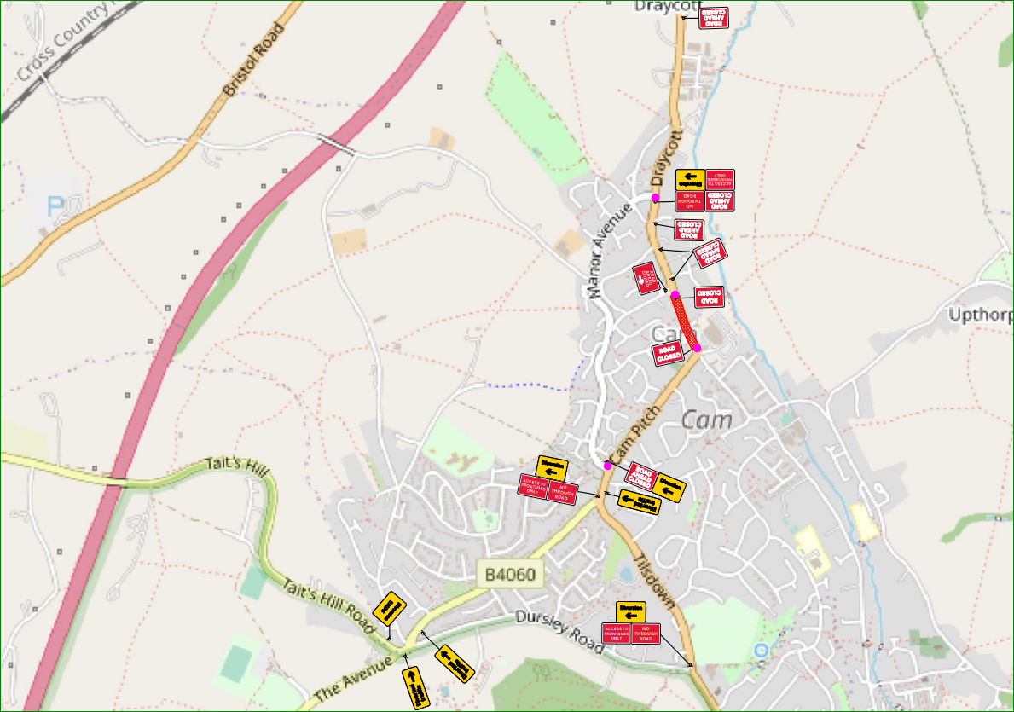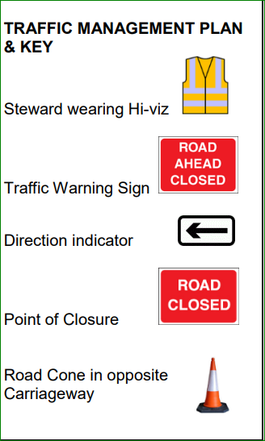

Hazards Identified | Those at Risk | Risk level before control measures S x L = R |  |  | Controls of Risk | Risk level after control measures  S x L = R
 |  | S | L | R |  | S | L | R
MANAGEMENT OF SAFETY and clear responsibilities | Parish Council member. Members of the public. Staff | 3 | 2 | 6 | - Specific responsibilities communicated clearly to all staff and volunteers during briefings: fire wardens (all), traffic control, first aid etc.  - Public Liability Insurance cover the event. Contractors providing equipment or entertainment have provided their own Public Liability Insurance (copied held on file). | 3 | 1 | 3
TRAFFIC MANAGEMENT  Collision between vehicles and pedestrians | Parish Council member. Members of the public. Staff | 3 | 2 | 6 | - Traffic management plan in place. Barriers will be in place to prevent vehicle access. Only exhibitors and contractors will be permitted controlled access to the site from 09:00 – 11:00. 11:00 – 17:00 access for disabled parking only.  - Advance communication with all residents to support short term closure for event  - SIA Stewards/ Traffic Control wearing high visibility vests will make sure vehicles do not Everside Lane from only access point.  - Public have been advised to walk where possible to reduce the number of vehicles near site  - All contractors/ exhibitors advised of access times and arrangements  - Access to be maintained for emergency vehicles at all times.  - Radio contact between traffic control and other support staff.  - All exhibitors and contractors have been communicated with regarding speed limit on Everside Road.  - Traffic marshals placed at midpoint of road to help direct and control limited event traffic.  - Traffic marshals placed at midpoint of road to ensure no traffic is permitted near pony rides | 3 | 1 | 3
Manual handling: Musculoskeletal  injuries | Parish Council members, Staff, Contractors | 3 | 3 | 9 | - Manual handling will be limited  - More than two people to help lift heavy items  - All stall holders and contractors have completed their own risk assessments to review and reduce risk  - Persons experienced in manual handling of own equipment and materials  - Deliveries to be made as close as possible to point of use | 2 | 2 | 4
Emergency arrangements & First aid provision  Hazards arising from the need to evacuate or another emergency situation. | Parish Council member. Members of the public. Staff. Contractors. Stall holders. | 5 | 3 | 15 | - First aid provided by external company and meets medical risk rating of event (-20) and will be highly visible at the event. Adequate cover is in place.  - First aid will be available for use if needed in Event Control (Pavilion)  - Evacuation anticipated to be very unlikely and if required, access to neighbouring field, housing estate or Everside Lane is possible (depending on any restrictions).  - Emergency announcements made over PA to give clear instructions to the public (schedule of appropriate cover to be in place for Event Control)  - Radio communication between Stewards, First Aid and Event Staff | 4 | 2 | 8
ELECTRICAL SUPPLIES  Shock, burns, equipment  damage | Parish Council member. Members of the public. Staff. Contractors. Stall holders. | 5 | 2 | 10 | - Advance planning shall determine specification of appropriate power supplies and distribution equipment  - Equipment to be supplied as thoroughly inspected and safe for use by the contractor  - Equipment sited to allow free access of ventilation and prevent contact with materials likely to assist the spread of flame  - All exhibitors and contractors requested to ensure all electrical appliances have valid PAT testing in place (copies held on file) | 5 | 1 | 5
LOST CHILDREN/ PERSONS  Method for reuniting lost  persons | Members of the public. | 5 | 2 | 10 | - Organiser to carry out a pre-event site visit to ensure that the area is suitable for young persons.  - All staff briefing to include lost child point: Event Control. Event organiser will be lost child designated person, and has DBS in place  - Event code word and actions for what to do if lost child is reported (location last seen, clothing description etc) given during briefing  - If young person is lost and not found within 10 minutes, police will be notified | 5 | 2 | 10
Adverse weather  conditions | Parish Council member. Members of the public. Staff. Contractors. Stall holders. | 3 | 3 | 9 | - Assess on the day whether the event is safe to go ahead in heavy wet weather or high winds conditions. The Clerk to the Council will make the final decision.  - Review the situation during the course of the event and make any necessary decisions as to the safety of attractions | 3 | 1 | 3
CROWD MANAGEMENT  Overcrowding leading to  crowd crushes and adverse  dynamics | Parish Council member. Members of the public. Staff. Contractors. Stall holders. | 3 | 2 | 6 | - Large open plan green space will naturally ensure adequate circulation space available for likely audience less than 1,000  - Clearly identifiable fully briefed stewards to assist where necessary  - Staff to be aware of demographic in attendance, and protocols for any anti-social behaviour  - Local PCSO neighbourhood team invited to attend  - SIA and stewards in attendance (7 SIA stewards, communication via radio)  - No licensable activities taking place  - All egress points are clear, sufficient and will remain unobstructed  - Audience demographic is low risk: mixed, family  - Timing of event will not encourage late night drinking or anti-social behaviour etc.  - Disruptive persons to be identified by event staff and responded to appropriately i.e., asked to leave by SIA operatives  - A reasonable amount of alcohol is permitted to be carried into the event as part of a picnic. SIA stewards will monitor and ask event attendees to de-cant into plastic glasses. Any amount of alcohol deemed above acceptable will be confiscated and returned to owner the following week. All of this supports The Licensing Act 2003 objectives. | 1 | 3 | 3
PUBLIC INFORMATION  Local concerns and objections | Parish Council member. Members of the public. Staff. Contractors. Stall holders. | 1 | 3 | 3 | - Advance communication with all event neighbouring residents, by letter, poster and social media  - Consideration given to time and noise level relevant to local residents.  - Advance liaison with emergency services  - Social media, letter drops, and email utilised in forewarning of event or can be used in event of cancelation | 1 | 1 | 1
Slips/trips/falls:  Injuries arising from slips, trips and falls | Parish Council member. Members of the public. Staff. Contractors. Stall holders. | 4 | 3 | 12 | - Any slip/trip hazard to be reported to a member of the Council so they can clear the hazard.  - All footpaths and access routes to be monitored during event to ensure no hazard build-up  - All footpaths and access routes to be monitored throughout event to ensure potential obstructions and hazards are identified and dealt with quickly  - Emergency routes to be kept clear at all times (included in plan)  - Public open spaces present some obvious trip/slip risks but normal for this type of environment  - Lighting: will not be an issue for the scheduled time of event (inc. build-up, open and break-down)  - Any defective or clearly hazardous areas to be temporarily barriered until remedial work can be undertaken  - Cables to be routed by matted/taped down | 4 | 1 | 4
Gazebo & equipment: injuries caused by faulty equipment | Parish Council member. Members of the public. Staff. Contractors. Stall holders. | 2 | 2 | 4 | - Gazebo to be checked and in good working order before use  - At least one member of staff with experience of putting gazebo up to be in attendance  - Allocated time for set-up will ensure safe working practise  - Al stall holders have submitted risk assessments for their activities  - All working at height must be avoided wherever possible, and is not anticipated for this event | 2 | 1 | 2
Food Hygiene | Parish Council member. Members of the public. Staff. Contractors. Stall holders. | 5 | 3 | 15 | - All purchased refreshments will be made at designated catering providers, who operate under their own hygiene rating and catering business  - all catering providers have a food hygiene rating of 4+  - All catering outlets have access to running water for hygiene purposes if required  - The Event Organisers will monitor activity which could lead to poor food hygiene and react accordingly where trends are identified. | 4 | 1 | 4
GENERAL FIRE RISKS  General risks from fire, smoke, ignition sources, confusion and panic in the presence of danger | Parish Council member. Members of the public. Staff. Contractors. Stall holders. | 5 | 3 | 15 | - Regular patrols by all staff and stewards to ensure no unauthorised fires  - All catering suppliers have a risk assessment in place, and fire preventative action methods and equipment  - Event has limited all sources of ignition and shall separate them from sources of fuel.  - Additional fire extinguishers are on hire for the temporary marquee | 5 | 1 | 5
PERFORMANCE GROUPS | Performers | 3 | 2 | 6 | - Young and vulnerable people supervised or assisted by appropriate adults or assistants  - Activities for children to not include any hazardous tasks, substances or inappropriate material  - Each entertainment provider and stall holder has provided a risk assessment for their activities, and a copy of their Public Liability Insurance.  - Skate park use will be closely monitored by Youth Worker to prevent overcrowding or dangerous manoeuvres. The facility will be used for it’s intended use. | 3 | 1 | 3
Welfare Arrangements  Lack of toilet  facilities, public  hygiene | Parish Council member. Members of the public. Staff. Contractors. Stall holders. | 3 | 2 | 6 | - Sufficient welfare facilities provided for expected numbers and demographic of attendees, and length of event  - Location of welfare facilities will be communicated with public at event via highly visible stewards  - Welfare: min. of 5 toilets required for expected number attending event for 6 hours with mixed gender and food being served. Event has provision of 7 toilets.  - Cleanliness of toilets will be monitored at regular intervals throughout the event. | 2 | 1 | 2
ANIMAL HANDLING  Public safety | Parish Council member. Members of the public. Staff. Contractors. Stall holders. | 5 | 2 | 10 | - Animals will be supervised at all times  - Any handling will be supervised by expert handlers  - Hand sanitiser and handwashing facilities available following handling to prevent any infection  - Adequate barriers in place to ensure controls of animals during exhibit and prevention of public walking into animals  - Animal welfare documents and risk assessment for activity on file | 3 | 1 | 3
STRUCTURAL FAILURE  Leading to collapse or overturning of temporary structure | Parish Council member. Members of the public. Staff. Contractors. Stall | 3 | 2 | 6 | - Temporary structure in place: marquee. All safety checks and final sign off by qualified contractors. Contractor safety policies on file.  - Any structures designed for anticipated use and confirmed as suitable by competent persons  - Wind and weather contingency plan in place  - Appropriate ballast or anchoring in place (e.g., gazebo weights) for all relevant structures to prevent uplift, overturning or failure within limits of wind and weather management plan.  - Wind and weather monitored throughout event period and managed accordingly | 1 | 2 | 2
Natural Hazards  Eg: skin rash from plants, bee stings etc | Parish Council member. Members of the public. Staff. Contractors. Stall | 3 | 2 | 6 | - As part of regular grounds safety checks the play areas and playing field will be checked for any natural hazards. Checks are documented and actioned through the main office.  - Adequate first aid arrangements have been provided (proportionate to the level of risk). | 1 | 2 | 2

Risk Analysis Matrix |  | Severity
 |  | Negligible (1) | Minor (2) | Moderate (3) | Severe (4) | Critical (5)
Likelihood | Very High (4) | Low 4 | Medium 8 | High 12 | Very High 16 | Very High 20
 | High (3) | Low 3 | Medium 6 | High 9 | High 12 | Very High 15
 | Moderate (2) | Very Low 2 | Low 4 | Medium 6 | Medium 8 | Medium 10
 | Low (1) | Very Low 1 | Very Low 2 | Low 3 | Medium 4 | Medium 5

