|  |  |
| --- | --- |
| Meeting | Recreation& Leisure |
| Date | Wednesday 15 November 2023 |
| Report Title | Teen Shelter Update |
| Author: | Johnna Edwards. Projects Officer |

Officer’s Recommendations:

1. To note update on project

Background:

Minutes taken from Recreation & Leisure Committee meeting held on Wednesday 19 July 2023 (RL.23.034):

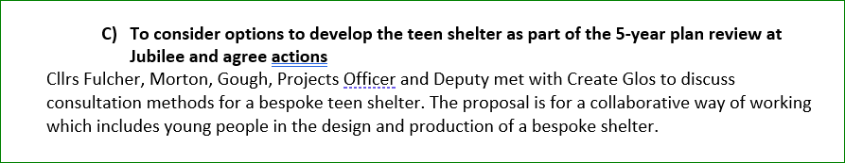

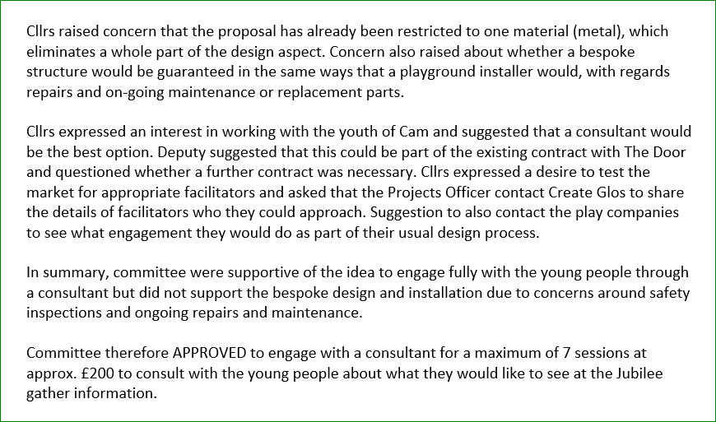

Minutes taken from Recreation & Leisure Committee meeting held on Wednesday 20 September 2023 (RL.23.045:

The call-out was advertised in October on social media, posters and the CPC website.

Facebook:

Shared by Create Glos through networks.

Poster displayed at parks/ Parish notice boards:

To do: press release

Key Dates:

Monday 11 December – deadline for submissions

Tuesday 19 December – hold for interviews

Submissions received so far:

1