MINUTES FROM A MEETING OF

RECREATION & LEISURE COMMITTEE WEDNESDAY 15 NOVEMBER 2023 AT 6.30PM

AT CAM PARISH COUNCIL OFFICE, 4 NOEL LEE WAY, CAM

Present: G Gough (Chair), J Fulcher, S Temlett, D Andrewartha,
Apologies: M Clifton, J Bishop, M Morton,
Absent:
In attendance: L Biddle (Deputy Clerk), J Edwards (Projects Officer), Cllr Chandler, Cllr Dormer

Chair opened the meeting and welcomed everyone present.

- To receive apologies for absence.
Apologies were noted as above

- To receive declarations of interest or requests for dispensations.
None

- To receive any questions, statements, or submissions from members of the public in
attendance (20 minutes total).
None

- Approve and sign minutes of the meeting held October 2023 as a correct record.
Committee RESOLVED to approve the minutes as a correct record.

- To note any matters arising from the minutes and not covered by agenda Items, for information only
None to note

- To note any progress made on the action plan
Westend boundary footpath – planning application for an additional house on the plot has been refused but there is still one house going in. Committee RESOLVED to continue to wait for the developer to decide about

Kissing gates – Cotswold wardens are struggling to identify a few landowners. Projects Officer to meet with Cotswold Wardens to progress. Cllrs raised concerns about the safety of some of these styles which are dangerous. Committee asked that the kissing gates are purchased and installed. Projects Officer will laminate a letter and pin it to the styles requesting the landowner contact Cam Parish Council.

- Projects
- To receive report on the Teen area consultant and agree actions
Project in running in line with timescales. Call out is being advertised and there has been some interest.

- To receive update on the Christmas event and agree actions
Committee received the update on the Christmas event.
Committee RESOLVED to approve the current budget activity.

Committee RESOLVED to agree draft risk assessment
Committee RESOLVED to agree draft traffic management plan

- To receive update from Jubilee field 5-year action plan working party and agree actions
The Jubilee Playing Field Working Party met on Monday 30 October. Attending Councillors: Fulcher, Fowler, Bishop & Gough. Apologies and comments from Cllr Cliffton received. The Working Party reviewed the existing Jubilee Playing Field 5-year-plan.

Concern was raised that the Section 106 money would be some time coming as the trigger is 350 houses at Draycott.

Committee RESOLVED to accept the recommendation from the working party as follows -

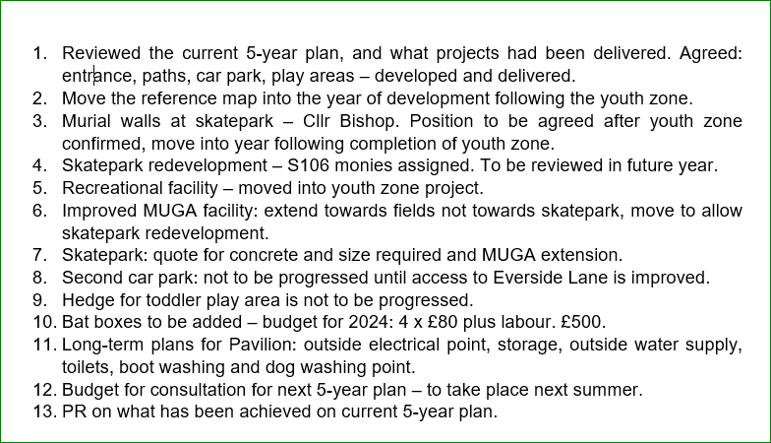

- Play Areas
- To note the monthly inspections, highlight any problems and agree remedies/ actions
Committee RESOLVED to note the monthly inspections for November.

- To note Handyperson inspections and agree actions
Committee RESOLVED to note the handyman inspections. Deputy will request an update on the branch overhanging the toddler slide at Jubilee.

- Allotments
- Receive allotment report from Chair/ Deputy and agree actions
There are still a few outstanding annual invoices which the Deputy is chasing.

The waiting list is not very long with most requests coming from the Woodfields area.

Committee RESOLVED to formally ask the liquidator of the Middle Mill site if they would be willing to sell the allotments as allotment land. This will be referred to Full Council for discussion.

- Receive allotment competition report and agree actions
Committee received a report from Cllr Clifton who they thanked for her input and RESOLVED not to run a competition next year.

- Discuss any issues of concern and agree actions
None to note

- Receive progress report on Rackleaze
9 Kerry Food corporate volunteers attended the last working party.

15-year lease is now signed and completed with Tesco.

A third quote is still needed for grit boards to fit on the boardwalk. This spend will be recommended to Full Council who manage the Rackleaze budget.

Committee discussed the importance of the Rackleaze in what may become a heavily populated area and expressed a desire to secure both sides of the river as a nature corridor. This will be added to a Full Council agenda for discussion.

- To approve payment to Cllr Clifton of £63.73 from Blooming Cams budget and to delegate the remining budget to Clerk and Cllr Clifton
Committee RESOLVED to authorise the payment of £63.73 to Cllr Clifton.

Committee RESOLVED to delegate the administration of the remaining budget for Blooming Cam to the Clerk and Cllr Clifton.

- To approve tree survey through SDCs approved contractor
Clerk asked that we bring the tree survey forward in order to budget for any resulting tree works in the next financial year. Quote received for the surveying from SDCs tree contractor. A comparable price from Tree Care consulting in February 2023 was £1,260. As SDC have been through the formal procurement process, and I’ve tested the market with another quote to compare, we don’t need to do anything more in terms of quotes or procurement.

Committee RESOLVED to award the Tree Surveying Contract of £550 + VAT through the SDCs approved contractor Glendale for -
Map your property digitally
Inspect all trees within your property boundaries
Assess the risk of harm presented by the trees and recommend remedial work
All findings presented both digitally and in a written report
(Technical specification to be the same as SDC contract)

- To approve 3-year contract with The Play Inspection Company for annual playground inspections
All play areas are inspected annually in line with legislation. Deputy sought quotes for the annual play inspections as follows

Company 1
2024 – 4 x £99.75 excl. VAT total £399
2025 – 4 x £104.50 excl. VAT total £418
2026 – 4 x £109.50 excl. VAT total £438

Company 2
2024 - £ 150.00 + £ 125.00 + £ 150.00 + VAT total £425
2025 - £157.50 + £127.50 + £157.50 + VAT total £442.50
2026 - £160.00 + £130.00 + £160.00 + VAT total £450

Company 3 – Routine inspections only
Company 4 – no reply
Company 5 – No reply
Dursley Town Council – not in a position to work jointly

Committee RESOLVED to award the 3-year contract for Annual play inspections to Company 1 The Play Inspection Company at a cost of
2024 – 4 x £99.75 excl. VAT total £399
2025 – 4 x £104.50 excl. VAT total £418
2026 – 4 x £109.50 excl. VAT total £438

- To approve allotment society renewal at a cost of £66
Committee RESOLVED to renew this subscription at a cost of £66

- To review the budget and agree actions
Cllr Temlett requested an update on planting Oak saplings to be added to a Full Council agenda.

With no further business the Chair declared the meeting closed at 20:10pm

