

**CAM PARISH COUNCIL**

**MINUTES OF A MEETING OF THE PLANNING & HIGHWAYS COMMITTEE ON**

**WEDNESDAY 13th NOVEMBER 2019 at 6.30pm at**

**CAM COUNCIL OFFICE, 4 NOEL LEE WAY**

NB Members of the public in attendance will be given the opportunity under Agenda item 3 to address Committee on any issue on the agenda (max. total of 20 minutes, 5 minutes per person)

**MINUTE**

1. **To Receive and Accept Apologies for absence**Apologies were received and accepted as above
2. **To Receive Declarations of Interest and Requests for dispensations**None received
3. **To receive any questions, statements or submissions from members of the public in attendance**1 Resident present – Concerns were noted regarding the excessive parking situation on Rowley and occasional speeding. Parking reported to be progressively getting worse within the last 18 months – Too many vehicles with no enough car parking spaces, parking over the footpath and inconsiderately. Pcso & Neighbourhood Warden to be notified to see if anything can be done – Clerk to pursue.
4. **To Approve and Sign Minutes of the meeting held September/October 2019 as a True and Correct Record**   
   The minutes of October and November were signed as a correct record
5. **To Note any Matters Arising from the Minutes and Not Covered by Agenda Items, (for Information Only).**None raised
6. **To note new planning applications in the parish**

[**Replacement of side porch (375866 - 199296)**](https://publicaccess.stroud.gov.uk/online-applications/applicationDetails.do?keyVal=Q02UFQPNI1U00&activeTab=summary)  
5A Springhill Cam Gloucestershire GL11 5PERef. No: S.19/2305/HHOLD   
No Observations

[**Removal of existing conservatory to be replaced with new single storey extension (375015 - 201866)**](https://publicaccess.stroud.gov.uk/online-applications/applicationDetails.do?keyVal=Q02UFCPNI1Q00&activeTab=summary)9 Box Road Avenue Cam Gloucestershire GL11 5DN  
Ref. No: S.19/2303/HHOLD   
No observation

[**1x 42" LCD media screen and 2x 1250mm x 700mm flag pole signs (374978 - 200411)**](https://publicaccess.stroud.gov.uk/online-applications/applicationDetails.do?keyVal=PZVWPHPNHWA00&activeTab=summary)  
Tesco 2 High Street Cam Dursley Gloucestershire GL11 5LE  
Ref. No: S.19/2280/ADV – No Observations

[**Minor amendment to the application S.18/1820/REM - Bin store attached to HA apartments changed from brick structure to timber enclosure (375189-201773)**](https://publicaccess.stroud.gov.uk/online-applications/applicationDetails.do?keyVal=PZS5Y9PNHQ500&activeTab=summary)Parcel H1 Box Road Cam Glos Ref. No: S.19/2265/MINAM  - refused, not discussed

[**Dormer extension and single storey rear extension ( 375220 - 199538)**](https://publicaccess.stroud.gov.uk/online-applications/applicationDetails.do?keyVal=PZQ9YNPN0D300&activeTab=summary)  
42 Ryder Close Cam Gloucestershire GL11 5SG  
Ref. No: S.19/2243/HHOLD- No observations  
  
[**Addition of trellis to existing garden fence at rear of property (Retrospective)**](https://publicaccess.stroud.gov.uk/online-applications/applicationDetails.do?keyVal=PYZVMUPNGPY00&activeTab=summary)  
5 Chapel Street Cam Gloucestershire GL11 5NX  
Ref. No: S.19/2140/HHOLD – No observation  
  
[**Discharge of condition 32 on permitted application S.15/2804/OUT - Statement, site plan, CIRIA SUDS Manual extracts. (375148 - 201237)**](https://publicaccess.stroud.gov.uk/online-applications/applicationDetails.do?keyVal=PYUFB6PNGN000&activeTab=summary)  
Land North East Of Draycott Cam Gloucestershire  
Ref. No: S.19/2128/DISCON - Noted  
  
[**Discharge of condition 31 (S104 confirmation of Technical Compliance from Severn Trent) of S.15/2804/OUT (375165 - 201793)**](https://publicaccess.stroud.gov.uk/online-applications/applicationDetails.do?keyVal=PYSYNWPNGLE00&activeTab=summary)  
Parcel H1 Box Road Cam Gloucestershire  
Ref. No: S.19/2113/DISCON – decided, not discussed

[**Erection fence around garden (Retrospective) (374231 - 199499)**](https://publicaccess.stroud.gov.uk/online-applications/applicationDetails.do?keyVal=PYFW1EPN0B900&activeTab=summary)  
8 Broadmere Cam Gloucestershire GL11 6PW  
Ref. No: S.19/2068/HHOLD – Objection. The fence has been installed forward of the existing building line and is out of keeping with the open nature character of the cul-de-sac.

[**Re-cladding of existing dwelling. Erection of rear extension and detached garage. Demolition of existing garage (376471 - 199982)**](https://publicaccess.stroud.gov.uk/online-applications/applicationDetails.do?keyVal=PYBSYRPNFXM00&activeTab=summary)  
34 Cam Green Cam Gloucestershire GL11 5HN  
Ref. No: S.19/2044/HHOLD – No Observations

[**Enclosure of existing porch. Erection of wall to enclose the rear garden (374544 - 200205).**](https://publicaccess.stroud.gov.uk/online-applications/applicationDetails.do?keyVal=PWZO2QPNM1T00&activeTab=summary)26 The Hawthorns Cam Gloucestershire GL11 5LJRef. No: S.19/1830/HHOLD   
No observations – request building not encroach on public footpath

1. **To note decisions in the parish**

*(decisions attached) - Noted*

|  |
| --- |
| **8.To note appeals or appeal decisions made within the parish** Land Adjacent 22 Cam Pitch Cam Dursley Gloucestershire |
| Erection of single detached dwelling, enlargement to existing parking area and associated works. **APP/C1625/W/19/3238135** |
|  |

1. **To note road closures in the parish (attached notification)**

Cllr Tipper welcomed the road re-surfacing completed and noted than more work had been completed in Cam than expected.

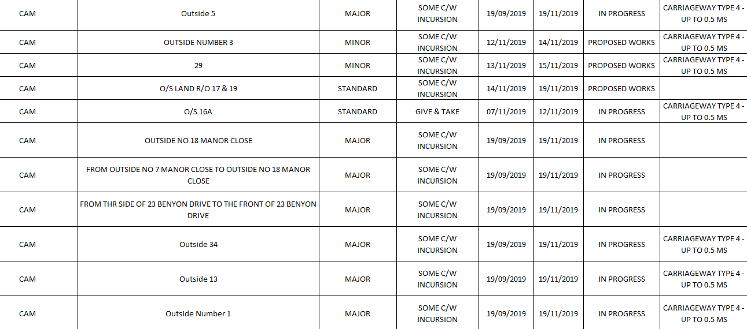

1. **To receive update on issues related to Parking at Cam Train Station**  
   Cllr Tipper reported contact with Glos Highways and awaiting response from Safety Audit expected shortly. Glos had been informed of land availability but no further information was available at this time. Cam & Dursley Transport Group were looking into adoption of the train station and it AGREED for Cllr Sherman to follow up with this community group the possibility of installation of lockers at the train station.   
     
   Local Transport Plan consultation expected in the Spring, Cllr Carter & Tipper to review with Clerk to ensure response from parish council within deadline.
2. **To receive information from SDRSG regarding available speed monitoring assistance and agree actions**No further meetings have been held to date, work ongoing with monitoring sample sites such as Rodborough and Minchinhampton.
3. **To agree response to public consultation for land off Tilsdown Cam for upto 25 dwellings.**Following the presentation from developers early in the evening, it was AGREED that the response could be formulated using the format sheet but a header should be inserted at the beginning of the document to say “Cam Parish Council will not support any applications for further large scale development until the effects of the previous strategic allocation are known and suitably addressed” in large bold text.  
   Document attached.
4. **To receive budget update and discuss recommendations for projects to FC for 2020 budget**Committee discussed future projects from the Planning and Highways Committee and it was AGREED to request the following for recommendation to full council.

2,000 Bus Shelters  
2,000 footpaths

1. **To receive request from SDC for happy to chat benches and agree actions**It was AGREED to approve to designate a “Happy to Chat” bench outside out parish office.
2. **To agree to purchase barrier and cones for events and safety requirements**It was RESOLVED to not purchase barriers/cones for parish business. 6 signs had been offered by Highways Officer and these had been collected from Stroud.
3. **To discuss issues regarding public footpaths (PRoW) and agree any actions**  
   Elstub Lane – cut back requested. It was noted that this had been recently completed
4. **To discuss issues regarding highways, paths, verges and hedgerows and agree any actions**Cllr Lane - Everlands, contact Wales & West regarding unsatisfactory completion of works.
5. **Any other Planning & Highways Matters for information or referral only**  
   Cllr Sherman noted transport meeting attending shortly with Cllr Tipper at GCC.

With no further business, the meeting was declared closed at 9.25pm.