**Cam parish Police report Oct - Dec 2023**

**Your Dursley & Cam Neighbourhood Policing Team**

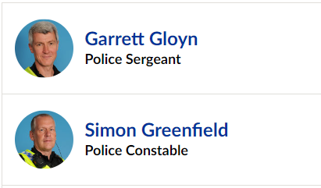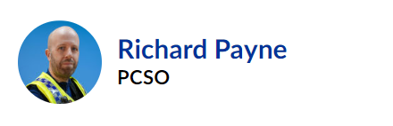

**Recorded crime**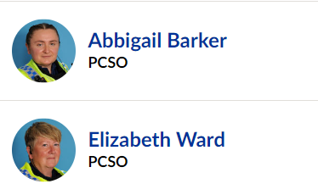

|  |
| --- |
| **Period : 01OCT2023 - 31DEC2023 Compared With 01OCT2022 - 31DEC2022** |

Cam parish

| **HO Band** | **Crime 01OCT23 31DEC23** | **Crime 01OCT22 31DEC23** | **+/-** | **% Crime Diff** |
| --- | --- | --- | --- | --- |
| Violence | 68 | 74 | -6 |  |
| Sexual Offences | 4 | 2 | +2 |  |
| Robbery | 3 | 0 | +3 |  |
| Burglary – Residential | 1 | 8 | -7 |  |
| Burglary – Business & Community | 0 | 0 | 0 |  |
| Theft – Other | 16 | 15 | +1 |  |
| Fraud | 0 | 0 | 0 |  |
| Criminal damage | 11 | 10 | +1 |  |
| Drugs | 0 | 2 | -2 |  |
| Other notifiable | 9 | 0 | +9 |  |
| = | 112 | 111 | +1 |  |

The crime figures for the quarter year on year are flat – a small reduction on violence and a good reduction in residential burglaries in the area. A small increase in robberies is noted and officers have been conducting high visibility patrols around the area.

Proactive work this quarter in the Dursley and Cam policing area (parishes of Dursley, Cam, Coaley, Stinchcombe, Uley, and Nympsfield):

* We have been working hard to deal with Anti-social behaviour in Dursley town centre – this has involved working with youth groups, town council, local businesses, community groups and schools. We have issued 7 ASB warning letters so far and have used restorative justice to allow offenders to recognise the effect of their behaviour on victims.
* We have been working with community speed watch and completing speed checks in Cam and Stinchcombe to monitor speeding and have sent letters to drivers who have exceeded the speed limit.
* We have visited The Scouts in Cam, and many primary schools in the district giving them chance to learn about the work we do and to be able to get in the police car and try uniform on.
* We have increased high visibility patrols in the evenings in Cam following the appearance of graffiti around the area.
* We have conducted licensing checks on premises in the area to ensure that premises are complying with the conditions of their premises licences.
* We have visited shops that sell vapes in the area to remind them of their obligations when it comes to selling vapes to children and to inform them that we will be conducting checks in the future using children attempting purchase to monitor compliance with the law.
* We have had our community engagement vehicle around the area including Dursley town centre and Tesco’s in Cam.
* A section 8 PACE warrant was executed in Uley, a male was charged and remanded with possession with intent to supply class A controlled drugs.
* We have maintained visits to The Prince of Wales hotel which is being used as a migrant holding facility – checking that everything is in order and offering support where needed.
* A male from Dursley has been remanded on conditional bail following a hate crime in the town
* Officers have attended addresses in Cam with Stroud district council to issue notices for contraventions of tenancy agreements.