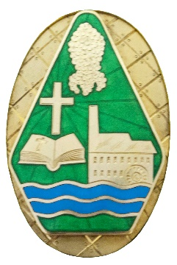 | Celebration Lights Policy  Cam Parish Council

Background

In January 2021, Council resolved to leave small LED lights in the seven trees around the small car park near Cam Parish Council Office and Froffy Coffee all year round. A successful funding bid was secured for £8,000 from Gloucestershire County Council’s Build Back Better fund towards the cost of buying and installing these lights in readiness for the Queens Platinum Jubilee celebrations in June and Christmas 2022.

Maintenance

The lights will be regularly loosened and rewrapped to allow for tree growth. This maintenance program will begin in June 2025 and every subsequent 3rd year. The trees remain in the ownership of Stroud District Council who reserve the right to carry out any necessary management.

Policy

The celebration lights will be turned on in line with the Cam Christmas Event OR at the end of November and controlled with a timer switch set at 4pm-10pm. The lights will remain on throughout the festive period and switched off on OR around the 6th January.

Full Council may consider turning the lights on for other occasions throughout the year on receipt of a written request to the Clerk. Full Council usually meets on the first Wednesday of each month with the agenda being prepared a week in advance. Requests should be sent in a timely manor in order for it to be included on an agenda prior to the date of the occasion. Please check the website or contact the office to confirm that a meeting will be called to avoid disappointment.

