Cam Parish Council Report

January – March 2024

Your Cam Neighbourhood Policing Team

* ASGT Sarah ROBINSON
* PCSO Liz WARD
* PCSO Richard PAYNE

Recorded Crime

**Period: 01Jan2024 – 31Dec2024 Compared With 01Jan2023 – 31Mar2023**

Recorded Crime

**Period: 01Jan2024 – 31Dec2024 Compared With 01Jan2023 – 31Mar2023**

Cam

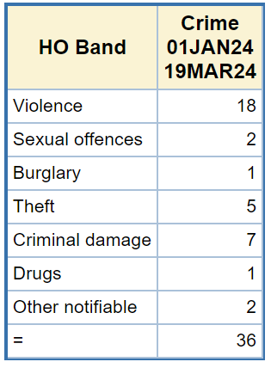

Work this quarter in the Cam policing area:

We have been conducting Hi-visibility patrols in and around the area in the evenings as we have had several thefts reported to us from outbuildings.

PCSO Ward has been working with SDC Housing with issues with some of their residents.

Lots of reassurance visits and house–house enquires following other incidents have been made

PCSO Ward will be leaving the team to join the Rural Crime Team on a Secondment