Meeting | Full Council
Date | Wednesday 3 April 2024
Report Title | Community Event Update
Author: | Projects Officer, Johanna Edwards

Officer’s Recommendations:
- To agree to wording on base of Tommy Soldiers.
- To receive an update regarding Christmas grotto location and implications.

80 Years – D Day Event:

- Tommy Soldiers: Council resolved in February to purchase 2 x the original Tommy Soldier. The statues have bene ordered. There are two options for engraving o the base of the statue, which Council need to decide on:
Option A: Lest We Forget.
Option B: We will Remember Them

- Cllr Temlett provided contact details for local veteran resident. The family of the veteran who had been part of the D-Day Landings at Gold Beach have been interviewed by Jo Lewis and the story is being written up.

- A history of Cam: Dursley Heritage Centre re-writing/ updating. Some images have been provided by family members. Jo Lewis is working on this with local residents.
- Risk assessment draft created by Projects Officer and sent to Cllr Gough for review, as per action plan.
- Insignia Replacement: invoice revived.

Budget Update:
No change to previous updates.

Summary of actions:

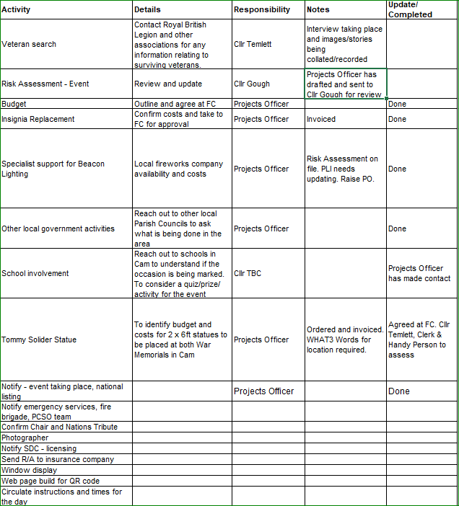

Christmas Community Event
- update from Acting Clerk regarding possoibility of moving Grotto to the Methodist Chruch, and the implications of this.
- The next community working party is on Wednesday 17 April at 5.15pm.

