

CAM PARISH COUNCIL,

4 Noel Lee Way, Cam, Glos GL11 5PS

www.camparishcouncil.gov.uk

MINUTES OF A MEETING OF FINANCE¸ POLICIES & GENERAL PURPOSES COMMITTEE HELD

WEDNESDAY 25th JANUARY 2023 AT 6.30PM AT

CAM PARISH COUNCIL OFFICES, 4 NOEL LEE WAY, CAM, GLOS, GL11 5PS

Present: JF,MM, DA,SA,MC Apologies: RL,BW,MG

In attendance: Clerk - J Walkley,

---------------------------------------------------------------------------------------------------------------------------------------------

- To receive apologies for absence
The apologies were received and noted as above

- To receive declarations of interest or request dispensations
None received

- To receive any questions, statements or submissions from members of the public in attendance
No comments noted

- To confirm minutes of the meeting of Nov 2022 as a correct record
The minutes of the meeting were approved and signed as a true and correct record.

- To note matters arising from the meeting
Cllr Clifton requested an update regarding the planting of the cherry tree – Clerk reported that it was in place and protection had been installed around it. Fire Marshall training was noted as still required.

- To receive request for defibrillator training from residents of Cam Green and agree actions
A resident who looks after the Upper Cam defib approached the council to request that the parish council could run another training session for residents and interested parties. It was considered that the machines are very much simplified and it was felt that it was not necessary at this time, it was RESOLVED to recommend to the group to make a grant request in the next round for funding towards the support of the machine.

- To agree increase in monthly fee for MS 365, emails and portal
Currencies globally have been impacted differently by the macroeconomic environment, which also affected the exchange rate compared to the US dollar. For a sustained period, Direct IT had deferred pricing adjustments based on such currency fluctuations, but as of April 1, 2023, Microsoft is realigning Cloud pricing globally. This means we are updating local currency cloud pricing in EUR and GBP based on foreign currency fluctuations compared to the US dollar (USD).

Starting April 1, 2023, the following adjustment will be effective for Microsoft Cloud services:
• British Pound (GBP) prices will adjust +10%
• Euro (EUR) prices will adjust +11%

It was noted that there was an update on the MS website stating that a 9% increase for British Pounds was expected. It was RESOLVED to accept a 9% increase and continue services with Direct IT support.

- To consider door repair quotes and maintenance contract
There are specific safety requirements for powered doors to ensure they are working effectively, and any potential issues are addressed. Doors should be serviced based on usage (and in compliance with the manufacturer’s instructions.) The minimum annual check for high frequency doors should include two separate appointments at least six months apart.

Quote 1 - Recommend 2 visits in line with legislation, Service & Minor adjustments with report
£195/ visit = £390/ year

Quote 2
Recommend 2 visits in line with Legislation, Service, Minor adjustments, Report - £215/ year

Quote 3
Recommend 1 visit per year, Service, Reduced call out fees
£65/ visit = £65/ year
I followed this up to enquire what a 2 visit per year cost would be –
2 visits – 6 monthly - the total annual cost would be £120

It was RESOLVED to accept Quote 2 and award the contract to Scott Security to the sum of £215 per year.

- To consider purchase of Parish Gazebo and associated equipment for events
3 quotes were provided for gazebo purchase. Discussion took place regarding a parish council branded gazebo but the item was deferred to allow staff to gather more information regarding the quality of the product and prices complete with walls.

It was RESOLVED to purchase a first aid flag of feather design, 2.3ft x 11.2ft including water weight/base – cost £143.22.

- To approve Rackleaze lease with Tesco for further 15 years
Committee received the new contract from Tesco which is a duplicate to the current lease that has been in place for the past 15 years. Clerk suggested solicitor representation to review the document. It was RESOLVED to accept the new lease, sign and return to Tesco for continued partnership working and protection of the Rackleaze area.

- To agree SLA with SVP to continue joint partnership working on the Rackleaze
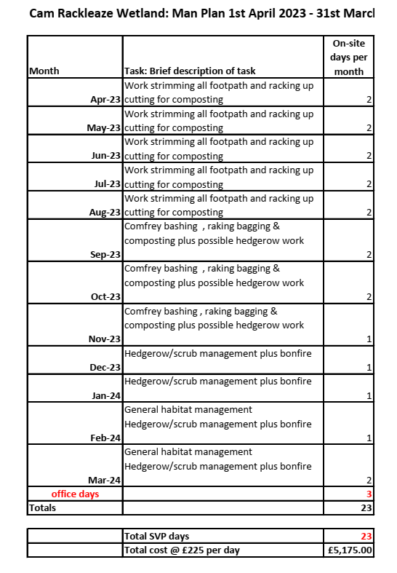

Cam Parish Council have worked in partnership with Stroud Valley Project for a number of years revitalizing and protecting the wetland area on the back on Tesco. It was RESOLVED to accept the continuation of joint parentship working and progress a longer term contract in place for the longevity of the project. It was RESOLVED to accept the quotation of £5175.00 for maintenance of the area for 2023/24 and request additional quotes for upgrades to the arrangement to allow for event days and survey work.

- To consider tender handy person contract and agree actions

- To consider tender pack for Grounds Maintenance 3 year contract and agree actions

It was RESOLVED to recommend to Full Council acceptance of the associated documentation the grounds and handyperson contracts for a 3 year term but allowing the amendments below:

- Reduction of grit/salt bin replenishment to bi-annually
- War memorial flower borders (twice yearly)
- Hedge at Woodfields annually cut
Hedges should be cut at appropriate times of the years ensuring safety of nesting birds where ever possible.
- To consider purchase of St Georges Flag/Armed Forces Day flag as agreed within flag flying protocol
3 quotes were provided for a woven polyester 2 yard flag. It was RESOLVED to purchase the St Georges flag in preparation for flag flying on St Georges Day.
Quote 1 - £46.95 - Approved
Quote 2 - £86.36
Quote 3 - £52.86

It was AGREED that the Union flag would be flown on Armed Forces Day and no parish council flag would be purchased until improved logo was created.

- To consider quotations for contracting of Planning Consultant in relation to SDC Local Plan Review hearings and agree actions
The Clerk gave the committee an update regarding the outcome of the working parties with CCAG and members and an update regarding the local plan examination. Contact had been made with Place Studio to enquire they could provide support, but the outcome had not been positive. 8 further companies had been approached for assistance and at point of the meeting - 2 had rejected, 1 quote had been promised and 1 had been received. It was RESOLVED to delegate authority to the clerk/chair to the value of £4900k to obtain necessary support engaging with consultant for written statements and hearing support from professional services budget.

POLICIES
- To consider creation of refugee policy
Discussions took place regarding this request. It was RESOLVED to not create this policy. All requests for support would be forwarded to the relevant local authorities and local support given as required. To be reviewed a later date.
- Any other matters for information or referral only
Pharmacy hours reduction and adequacy of facility
Business survey – Projects Officer progressing
Brown bin waste – request clearer assistance from SDC

With no further business, the meeting was closed at 20:11

