MINUTES FROM A MEETING OF

RECREATION & LEISURE COMMITTEE WEDNESDAY 13th MAY 2022 AT 6.30PM

AT CAM PARISH COUNCIL OFFICE, 4 NOEL LEE WAY, CAM

Present: F Poulter (Chair), M Morton, D Andrewartha, M Clifton, J Bishop, J Fulcher,
Apologies: R Lane,
Absent:
In attendance: L Biddle (Deputy Clerk), J Walkley (Clerk), 1 MOP

- To receive apologies for absence.
Apologies noted as above

- To receive declarations of interest or requests for dispensations.
None.

- To receive any questions, statements, or submissions from members of the public in attendance (20 minutes total).
None.

- Approve and sign minutes of the meeting held April 2022 as a correct record.
Committee APPROVED the minutes and were duly signed.

- To note any matters arising from the minutes and not covered by agenda Items, for information only
Letter has been sent by recorded delivery to the homeowner neighbouring the allotments at Upthorpe.

PROJECTS
- A) To receive update on Jubilee Fields development.
Pre-contract meeting on Wednesday 11th May.

Public display of information boards took place at the playing fields on Saturday 14th May. One MOP requested information on hiring the pavilion. Refer to FPGP along with the Terms and Conditions of Everside Youth FC.

MP Siobhan Bailey attended and would like more information on the installation schedule for the play area. Committee will have to decide how to engage with her to move projects forward.

B) to note the completion of the Cam accessible paths link from Littlecombe to Drake Lane.
5 kissing gates were installed at the beginning of May to complete this route. The gates were funded by Cam Parish Council and installed by The Cotswolds Wardens.

C) To note the completion of the celebration lights being wrapped in the trees around the car park.
Trees are due to be completed this week.

- To consider a Queens Jubilee Memorial Bench for the Jubilee Field.
Committee considered the price of the benches and the other things the Council have committed to for the Jubilee, including the flagpole and oak trees and decided not to commit to a bench.

- Play Areas
- To note the monthly inspections, highlight any problems and agree remedies/ actions.
Monthly inspections were noted. New inspection costs have been increased from £70 to £94 due to the increased operational costs and inspection software. Committee AGREED to 3 months with a review once the new play areas at Jubilee have been installed.

- To agree to allow GL11 Sunflower Project/ Holding Together to plant approx. 10 sunflowers at Jubilee Fields close to the two benches by the Skate Park.
Committee APPROVED the planting of sunflowers and did not stipulate how many

- Agree to purchase additional dog bags for dispensers (£12.50 for 200 eco bags plus postage of £5)
In January 2022, Committee agreed to purchase a three-month supply of dog poo bags for Jubilee Field. The installation of poo bags had been well received and it seems that the bags are being used and not abused. We expect use to increase during the summer months and with the installation of new play equipment. Committee are asked to decide if more bags are purchased and if so, how many.

Committee APPROVED to carry on supplying dog bags as it is in the public interest to keep on top of this issue. A delegated budget was APPROVED for £100 to get the most bags for this cost.

- Allotments
- Receive allotment report from Chair/ Deputy
Westend footpath is very overgrown. Handyman has been instructed to cut back.
Discussions with the developer regards substantial works to footpath are ongoing.
Tenants bordering the Upthorpe boundary have been requested to keep it clear for maintenance purposes.
First warning letters have been sent as per policy. Deputy will bring any escalated cases to committee if needed.

- Discuss any issues of concern and agree actions
A tenant at Woodfield’s reported stolen produce. She asked whether the perimeter fence could be replaced. This would need substantial investment and committee suggested adding to the Projects list for further investigation.

- Consider a Biodiversity Policy covering banned substances on allotments.
Committee suggested adding a section to the tenancy agreement regards substances on site.

Potential project to develop a Parish wide biodiversity and climate change policy including no mow zones, tree planting and wildflower areas.

- Consider fencing the slow worm section at the end of Ashmead 1 and putting up an information board.
Committee APPROVE a delegated budget of £50 to purchase an A4 dibond sign at a cost of £22.50+ VAT + delivery and a post to fix it to.

- Approve shed application for plot 22 at Woodfields
Committee APPROVED the shed application but requested that they consult with the Chair/ Deputy for the exact position.

- Receive progress report on Rackleaze and agree actions
Site is looking good. Mallard chicks and moorhen chicks on the balancing pond.
Three black poplars have been planted. Wood chip now extends the full length of the footpath.

Tesco lease needs formalising. Committee APPROVED a recommendation to Full Council to extend the lease by at least 25 years.

A discussion took place around the management of the balancing pond.

Cllr Bishop left the meeting at 20:01 and retuned at 20:01.

Committee requested a summary of progress and a long-term plan to take to a stake holders meeting involving Tesco, Stroud Valleys Projects and CPC.

This links in with the biodiversity policy and project to be progressed with the new projects officer.

- To receive the draft Canal Strategy Consultation update from Stroud District Council
In response to initial comments received regarding how to navigate the Canals Strategy material Stroud have included a new six-minute video which provides a walk through guide to the Strategy and how it was produced. They have also improved the format of some documents. The amended documents are available to view at www.stroud.gov.uk/canalstrategy

You can email your responses to: canals.strategy@stroud.gov.uk or send your response by post to: Planning Strategy, Stroud District Council, Ebley Mill, Ebley Wharf, Stroud GL5 4UB.

The District Council will consider comments and make any necessary changes to the documentation before adopting the final Canals Strategy at a future meeting of the Council’s Environment Committee.

- Budget update
Budget update received and noted

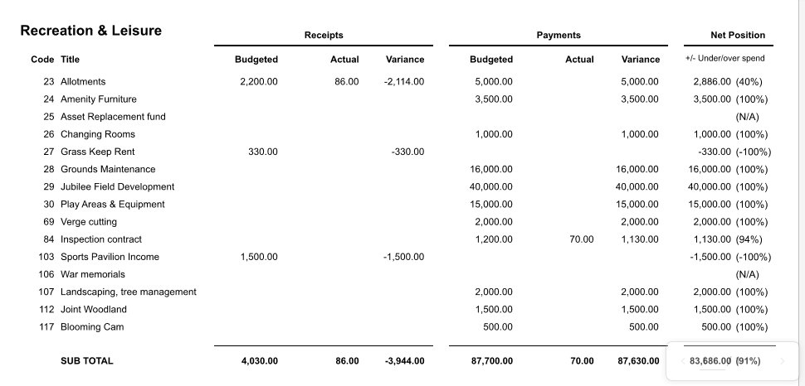

- Any further R&L issues for information or referral only
New App called Snowball which helps people with disabilities to find out what areas and services they can access.

Offer of a tree sapling which Joint Woodlands Management could take ownership of.

27th May tree planting ceremony organised by Dursley Town Council

Jubilee car park working party to meet again and progress.

Memorial tree and memorial bench project to be progressed by the new Project Officer.

With no further business the Chair declared the meeting closed at 20:25pm

