CAM PARISH COUNCIL

MINUTES OF A MEETING OF RECREATION & LEISURE COMMITTEE

WEDNESDAY 20 NOVEMBER 2019 AT 6.30PM IN THE COUNCIL MEETING ROOM

PRESENT: F Poulter (Chair), J Fulcher (Vice), C Carter
APOLOGIES: M Clifton,
IN ATTENDANCE: L Biddle (Deputy)

Meetings started at 6:39.

- To receive and accept apologies for absence.
Committee accepted apologies from M Clifton and noted the resignation of Cllr Lane.

- To receive declarations of interest or requests for dispensations
None

- To receive any questions, statements or submissions from members of the public in attendance
None

- Approve and sign minutes of the meeting held November 2019 as a correct record.
Approved and signed.

- To note any matters arising from the minutes and not covered by agenda Items, for information only
Bins for Jubilee have been ordered and will be delivered in the New Year.

- Allotments – Receive allotment report, comments from Chair and agree any resulting actions.
Formal letters were sent to the 4 non-payers with a deadline of 18th December to make payment. Payment has been received from 1 and contact made from another. As there is no waiting list, a home visit will be made and 1 final letter before eviction.

There are currently 4 vacant plots – Woodfields, Upthorpe and 2 at Westend.

- To agree to host an Allotments holders meeting in January/ February, consider speakers and agree arrangements.
Agreed to host an allotment holders meeting on 11th February at 6:30. Cllr Fulcher may know someone who could give a presentation. Advertise a seed swap, promote vacant plots, contact Leaf and Ground to donate seeds or have a stall.

Consider a February half term open event with simple workshops.

- Rackleaze Nature Reserve –
- To receive update from Cllr Fulcher on location for benches/ seating area and agree actions.
Committee RESOLVED to accept updated costs of £263 for the single bench in brown and £375 for the picnic bench in brown plus £46 delivery.

SVP will site them once delivered.

- To note update on improvement works at rackleaze and agree resulting actions.
Access ramps to boardwalk and a non-slip coating for the boardwalk are in hand but delayed due to wet weather. The boardwalk must be completely dry before applying products.

Committee RESOLVED to get the boardwalk varnished with a grit coating and the access ramps completed in the Spring through the handyman contract.

- Play Areas –
- To receive monthly play inspection reports and agree any action
Jubilee seesaw is to be looked at again by Greenfields as the recent repair has failed.

- To agree to replace the back-perimeter fence at Jubilee Playing fields and agree preferred contractor to complete works.
3 quotes considered. Committee RESOLVED to accept the quote from CH Stokes at a cost of £2,941.02 on the condition that a signed contract by both parties with a full specification of requirements are agreed as follows –
Round posts every 6-feet along the fence.
Metal cuffs fitted to the round posts to protect the posts from strimming damage.
Half-round rails fitted to the posts.

- To agree contractor to clear scrub at Jubilee at second entrance.
4 quotes considered. Committee RESOLVED to accept Copse and Loggers quote of £1,800 and not to carryout a scrap of surface.

- To agree to invite the ‘Friends of Jubilee’ to a meeting in January to update them on progress and set date.
15 volunteers have come forward.

Arrange to meet at Cam Parish Council office with drinks on Monday 20th January 2020 at 6:30- 8pm. Informal open evening and chat with mood boards and vision boards with some interactivity.

- To agree locations for 6 bins at Jubilee Field
Agreed to replace all basket bins.

- To discuss and put forward ideas for recreation and leisure opportunities as a result of development.
Boules court to be considered at Jubilee.
Bottom part of Ashmead 2 to be a community orchard.
Consider land around Jubilee for an orchard.

- To agree to regrind the Horse Chestnut stump at Hopton Green and turf over.
AGREED
- To investigate Tree Preservation Orders on trees around the parish and agree to get important trees included.
Cllrs Poulter and Carter to get together to progress.

- To agree to join Stroud District Councils tree contract.
AGREED

- To agree to repoint the stone steps at Cam Hopton Was memorial.
AGREED that the work should be done during a dry, milder period of weather in Spring.

- Budget update

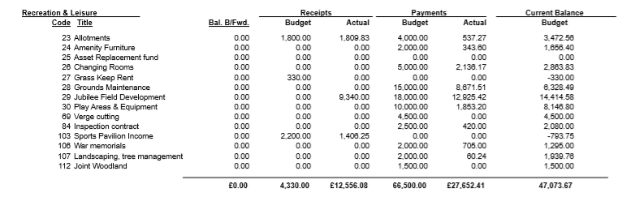
AGREED to suspend standing orders at 21:41 to complete agenda.

- Any further R&L issues for information or referral only
Low numbers on committee – promote at next Full Council to join.

Grants available for Ash tree replacement.

With no further matters to discuss, the meeting was closed at 21:58pm.

