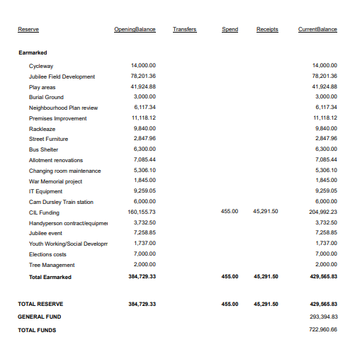
Jubilee field overspent – approx. £10k reducing to £68k
NDP - £2k – balance of £4117.34
Events – approx. overspent £3300– balance of £approx £4k (£500 possible grant repayment if requested)
Facilities 2300 overspend – balance of premises improvement reduced to £8818.12
IT - £1500 overspend expected – balanced reduced to 7759
Reduced by £19100
Increase play areas by £14k underspend – balance of £64000
Handyperson Contract/tools – (possible £3k underspend ) – balance to 6732.50
Increase by £17,000
Total earmarked with above calculations – £427465.83

