|  |  |
| --- | --- |
| Meeting | Recreation & Leisure Committee |
| Date | Wednesday 24 January 2024 |
| Report Title | Operational inspections |
| Author: | Deputy Clerk |

Officer’s Recommendations:

Committee to decide whether to award the contract to company 3 based on value for money or company 4 as it includes a routine maintenance visit

Background

There are three types of standard playground inspection:

1. **Routine Visual Inspection – playground inspections can be undertaken by council staff, maintenance operatives, councillors or community volunteers. These are weekly/fortnightly visual inspections and do not require any specialist or technical knowledge. Inspections should be recorded on paper or electronically, and a note made of any actions required and how any issues arising were dealt with. Ideally the inspection records should be kept on file by the council for 21 years**

CPCs routine inspections are carried out by DR Howse as part of the handyperson contract. A written checklist is received every week confirming that the site is visually in good condition or noting any issues such as litter, graffiti, etc and any other actions that need addressing.

1. **Operational Inspection – these are done every 3 months and need to be undertaken by an RPII qualified inspector who is trained to undertake minor repairs and maintenance**

CPC had a contract with Greenfields until January 2024 when they informed us they will no longer be offering this service. Greenfields attended every month which is over and above the legal requirement. I believe this set up was arranged when councillors were responsible for the routine inspections which were often not completed.

1. **Annual Inspection – these are done once a year by an independent playground inspector, ideally one approved by the Register of Play Inspectors International (RPII).**

CPC awarded a 3-year contract to The Play Inspection Company in November 2023 for its annual inspections in 2024, 2025 and 2026.

Deputy went out for quotes for quarterly operational inspections. Stroud District Council are not in a position to offer this service, neither are Dursley Town Council. 7 companies contacted and 4 have replied with quotes. The redacted quotes are available in the sharepoint folder for you to digest the details. A summary breakdown of cost is alone is below for information.

Company 1

We annually visit your area every April/May at the reduced rate currently charging £78.00 per play area to inspect up to five items of play equipment on the play area. There is an extra fee of £4.00 plus VAT to inspect each play item over five, so your quarterly inspections would take place in July, October, and January. We aim to complete the majority of the inspections in the month given, however there is a chance the inspection can fall into the following month during exceptionally busy times.

To break it down for you:

* April – Reduced Rate - £78.00 per play area to inspect up to five items of play equipment on the play area. There is an extra fee of £4.00 plus VAT to inspect each play item over five.
* July - £260 plus VAT for the first play area and then £115 plus VAT per subsequent area to be inspected on the same day.
* October - £260 plus VAT for the first play area and then £115 plus VAT per subsequent area to be inspected on the same day.
* January - £260 plus VAT for the first play area and then £115 plus VAT per subsequent area to be inspected on the same day.

**Total cost per inspection = complicated calculation based on number of items**

Company 2

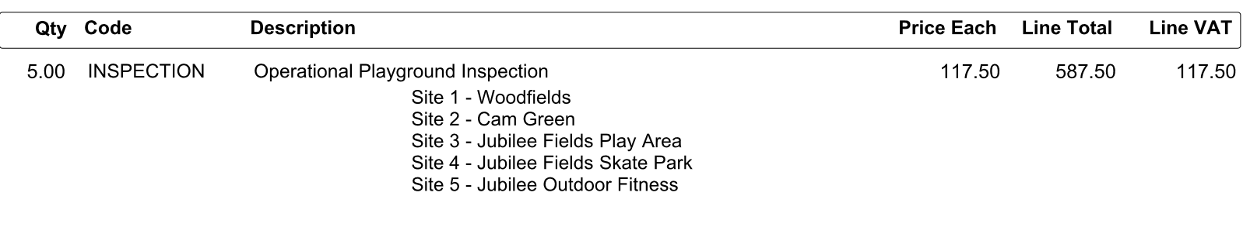

**Total cost per inspection = £587.50**

**Total cost per year = £1,762.50**

Company 3

Woodfields (Hadley Road) Operational Inspection 3 @ £125 = £375

Cam Green Operational Inspection 3 @ £125 = £375

Jubilee Playing Fields Operational Inspection 3 @ £125 = £375

**Total cost per inspection = £375**

**Total cost per year = £1,125**

Company 4

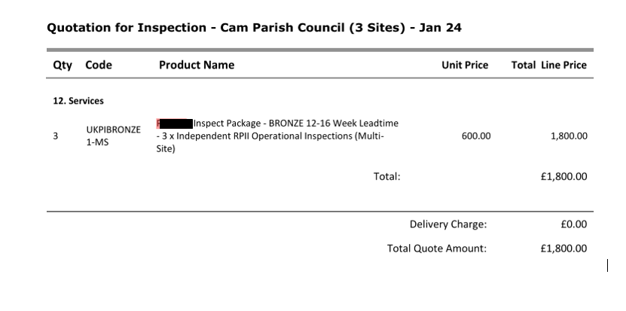

**Total cost per inspection = £375**

**Total cost per year = £1,125**